**DAILY ONLINE ACTIVITIES SUMMARY**

|  |  |  |  |  |  |  |  |  |
| --- | --- | --- | --- | --- | --- | --- | --- | --- |
| **Date:** | 05-06-2020 | | | | | **Name:** | K S Prajwal | |
| **Sem & Sec** | Vi A sec | | | | | **USN:** | 4AL18CS032 | |
| **Online Test Summary** | | | | | | | | |
| **Subject** | | N/A | | | | | | |
| **Max. Marks** | | N/A | | **Score** | | | N/A | |
| **Certification Course Summary** | | | | | | | | |
| **Course** | **Python and Django Full Stack Web Developer Bootcamp** | | | | | | | |
| **Certificate Provider** | | | Udemy | | **Duration** | | | **3 hr** |
| **Coding Challenges** | | | | | | | | |
| **Problem Statement:**  1: Program to find how many of the input numbers can be written as powers of 2  2: You are given an array of n numbers and q queries. For each query you have to print the floor of the expected value(mean) of the subarray from L to R. | | | | | | | | |
| **Status:** completed | | | | | | | | |
| **Uploaded the report in Github** | | | | | yes | | | |
| **If yes Repository name** | | | | | <https://github.com/alvas-education-foundation/KS_Prajwal> | | | |
| **Uploaded the report in slack** | | | | | yes | | | |

Online Test Details: (Attach the snapshot and briefly write the report for the same)

Certification Course Details: (Attach the snapshot and briefly write the report for the same)

Coding Challenges Details: (Attach the snapshot and briefly write the report for the same)

**Online Test Details: N/A**

Snapshot of certification course:

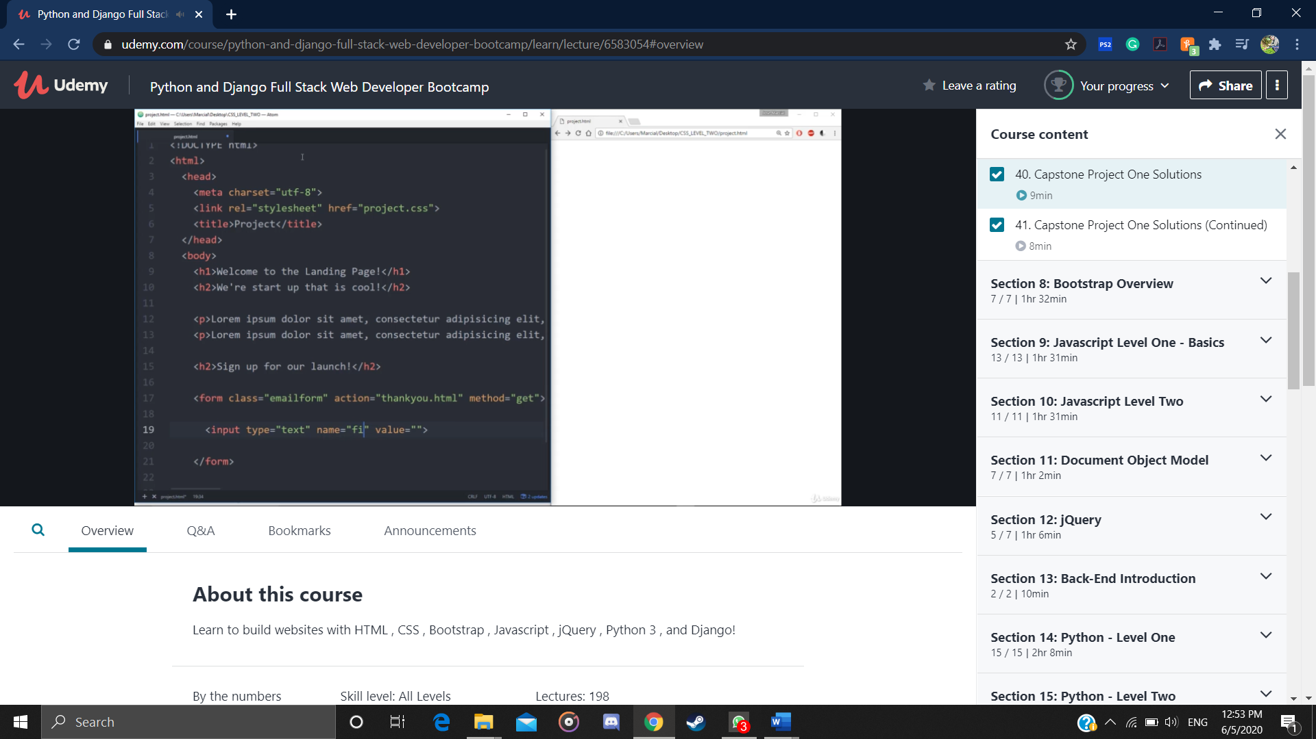

Today it was all about the capstone project they explained it and showed the demo on doing it.

**Online coding:**

Problem 1: (using python) Program to find how many of the input numbers can be written as powers of 2

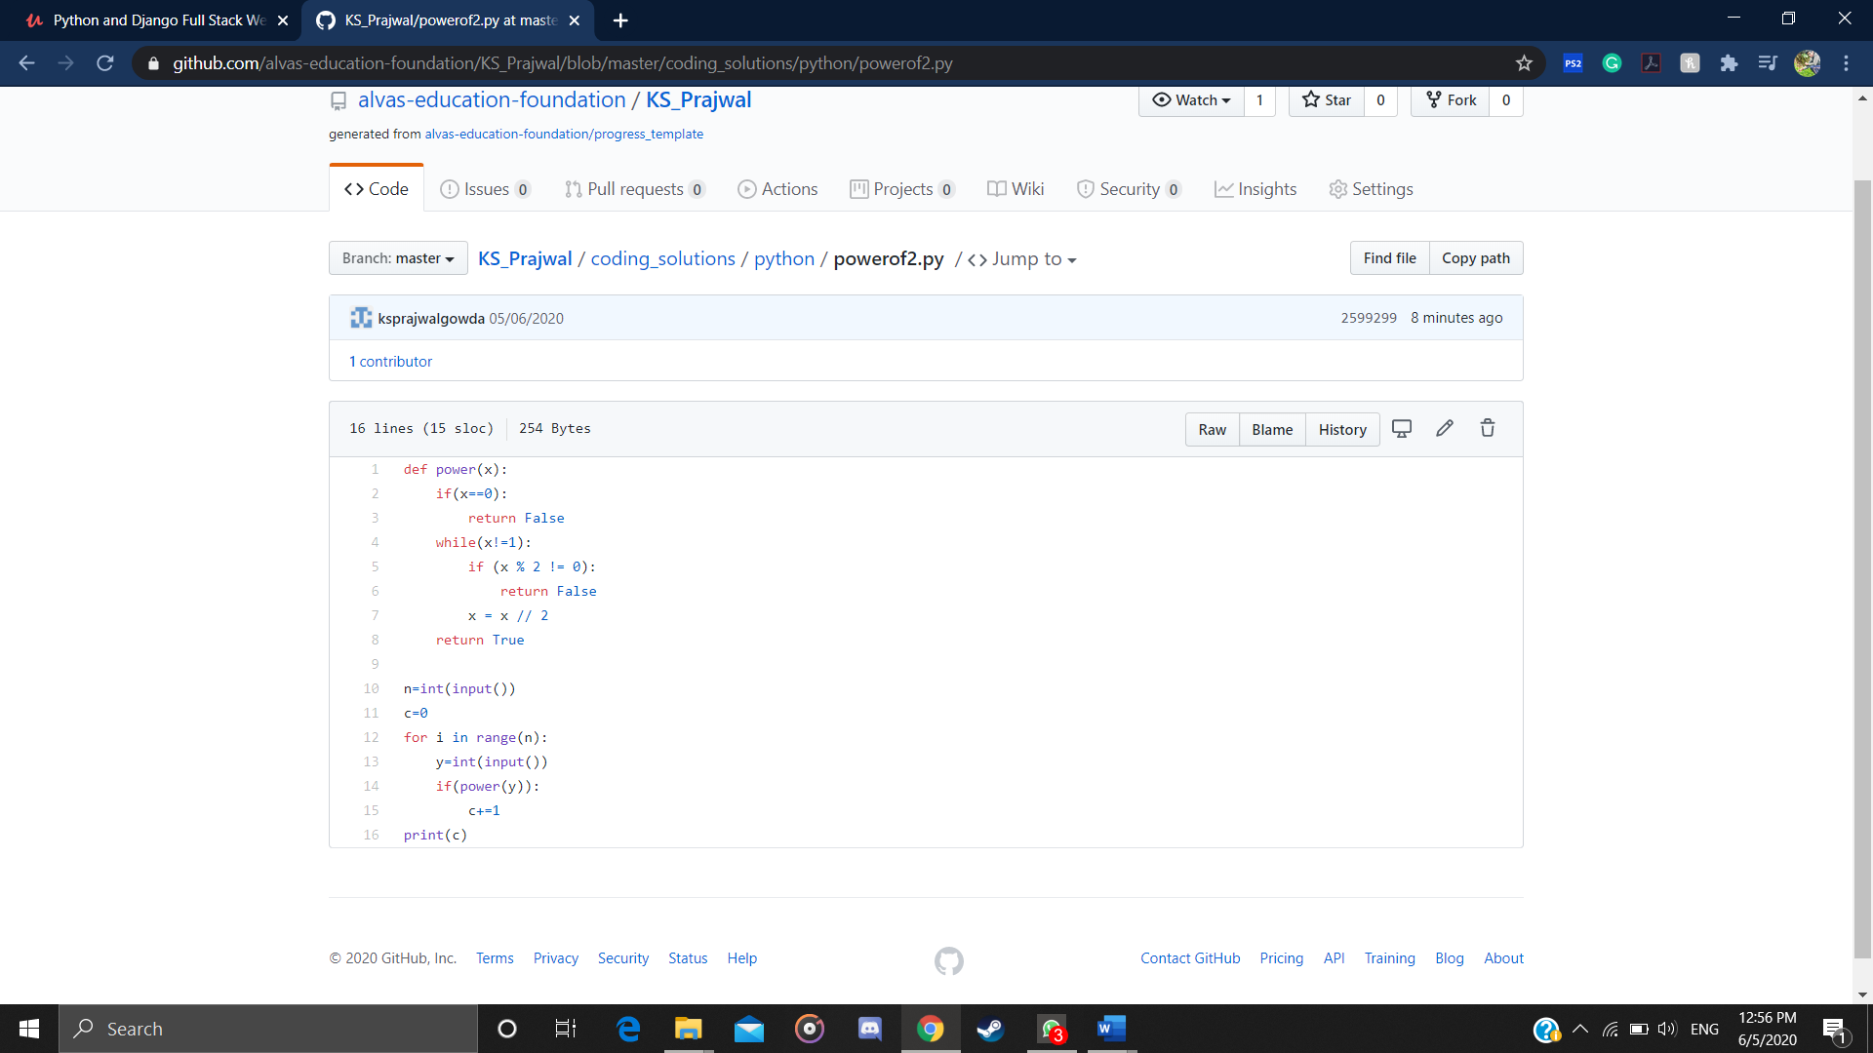

Problem 2: (using Python)You are given an array of n numbers and q queries. For each query you have to print the floor of the expected value(mean) of the subarray from L to R.

